ATTERBERG LIMITS TEST

AIM OF THE EXPERIMENT:-
The aims are fivefold: -
- To determine the liquid limit of fine grained soil.
- To determine the plastic limit of a fine grained soil.
- To classify the soil.
- To find the flow index.
- To find the toughness index.
APPARATUS REQUIRED:-
- Special:
- Casagrande’s Liquid limit device.
- ASTM & BS grooving tools.
- Glass plate.
- 425 micron IS sieve.
- 3mm diameter glass rod.
- General:
- Spatula
- Balance of 0.01 gm sensitivity
- Water content containers
- Drying oven
- Desiccators.
THEORY:-
Liquid limit is the water content corresponding to an arbitrary interface between the liquid and plastic states of soil. The true value cannot be determined unless it is specified by a standardized apparatus. For determination purpose, the liquid limit is that water contents at which part of soil, cut by a groove of standard dimensions, will flow together for a distance of 12.5mm under an impact of 25 blows in light liquid limit apparatus. The soils at the liquid limit has shear strength are about 17.6 gs/cm².
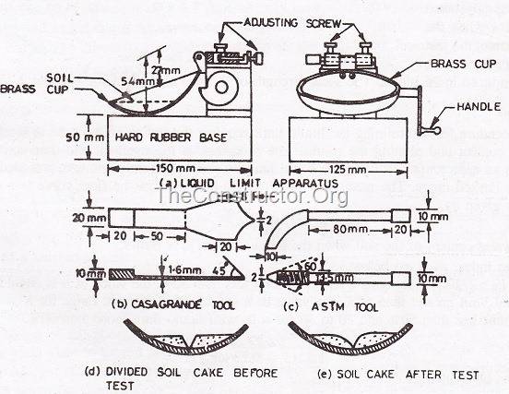
The water content at which soil has the smallest plasticity is called the plastic limit. Just after plastic limit the soil displays the property of semi-soiled material. For determination purpose, plastic limit is defined as the water content at which a soil begins to crumble when rolled into a thread of approximate 3mm in diameter.
The difference in the moisture content between the liquid limit and plastic limit is termed as plasticity Index. A fine grained soil may be classified with the help of plasticity chart according to IS soil classification system (IS: 1498-1970).
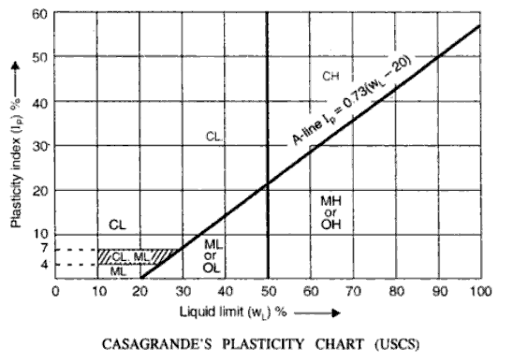
In plasticity chart symbols are used like,
Example: CL: Clay of Low compressibility;
MH: silt of High compressibility;
OI: Organic soil of Intermediate compressibility.
APPLICATION:
The values of the liquid limit and plastic limit are directly used for classifying the fine grained cohesive soil according to IS soil classification system. Once the soil is classified, it helps a lot in understanding the behaviour of soil, selecting suitable methods of design, construction and maintenance of the structures made up of or resting on soils.
The values of these limits are also used in calculating the Flow Index, Toughness Index, Plasticity Index Which are useful in giving an idea about the plasticity, cohesiveness, compressibility, shear strength, permeability, consistency and state of cohesive soils.
Atterberg (1911) has shown the correlation between the plasticity index, soil type, degree of plasticity and degree of cohesiveness as shown in Table below,
Plasticity index | Soil type | Degree of Plasticity | Degree of Cohesiveness
0 | sand | non-plastic | non-cohesive
< 7 | silt | low plastic | partly cohesive
7 to 17 | silty clay | medium plastic | cohesive
> 17 | clay | highly plastic | cohesive

PROCEDURE:
- For Liquid limit:
- Adjust the cup of the liquid limit apparatus with the help of grooving tool gauge and adjust the plate to give a drop of exactly 1 cm on the point of content with the base.
- Take about 120 gm of an air dried sample passing through 425 micron sieve.
- Mix it thoroughly with distilled water to from a uniform paste.
- Place a portion of paste in the cup of the liquid limit device, smoothen the surface with the spatula to a maximum depth of 1 cm. Draw the grooving tool through the sample along the symmetrical axis of the cup, holding the tool perpendicular to the cup.
- Turn the handle at the rate of 2 revolutions per second and count the blows till the two ends of the groove come in content.
- Transfer about 15 gm of the soil forming the edges of the groove to the water content container, and determine the water content by oven drying method.
- Repeat above steps. Obtain at least four sets of reading in the range of 10 to 40 blows.
- Using a semi-log paper, plot the points, taking number of blows on the log scale, and water content as ordinate. The plot is known as Flow curve. The water content corresponding to 25 blows gives the liquid limit.

- For Plastic Limit:
- Take about 30 gm air dried soil sample passing through 425 micron sieve.
- Mix thoroughly with distilled water on the glass plate till it is plastic enough to be shaped into a small ball.
- Take about 10 gm of the plastic soil mass and roll it in form of thread using the palm and the glass plate. If the diameter of the thread becomes less than 3 mm without cracks, it shows that water added in the soil is more than the plastic limit; hence the soil is kneaded further and rolled into a thread again.
- Repeat the rolling and remoulding process until the thread just starts crumbling at a diameter of 3 mm.
- Collect the crumbled soil thread at 3 mm diameter in an air tight container and determine its water content.

PRECAUTIONS:
- Use distilled water in order to minimize the possibility of ion exchange between the soil and any impurities in the water.
- Soil used for liquid limit and plastic limit tests should not be oven dried.
- In liquid limit test the groove should close due to the flow of soil and not due to the slippage between the soil and the cup.
- After mixing the distilled water with the soil sufficient time should be given to permeate the water through the soil mass.
- For each observation, the brass cup and the grooving tool should be cleaned.
OBSERVATION AND CALCULATION TABLE:
- For Liquid limit Determination:
Sr. No. | 1 | 2 | 3
No. of blows
Container No.
Empty weight of container (gm)
Wt. of container + Wet soil (gm)
Wt. of container + Dry soil (gm)
Water content (%)

- For Plastic limit Determination:
Note: - It is water content at which the soil thread of approximate 3mm diameter, develops cracks.
Sr. No. | 1 | 2 | 3
Container No.
Empty weight of container (gm)
Wt. of container + Wet soil (gm)
Wt. of container + Dry soil (gm)
Water content (%)

- Classification of soil:
Plasticity Index (PL) = Liquid Limit (W1) – plastic Limit (WP)
= _ _ _ _ _ _ _ _ _ _ _

From the plasticity chart the soil is classified as: _ _ _ _ _ _ _ _ _ _ _ _

- Flow index (I_{f} ):
It is the slope of the flow curve:
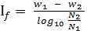
Where, w₁ = Water content in % at N1 blows,
w₂ = Water content in % at N2 blows.
- Toughness Index (I_{T}):
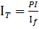
Where, I_{f} is the flow index and PI is the plasticity Index.
QUESTIONNAIRE:
- Two clays obtained from two different sites have different values of liquid limit. Are the shear strength values at liquid limit different or same?
- Name the other apparatus for liquid limit determination.
- If oven dried sample is used instead of air dried sample, what is effect on the liquid limit?
- If the heights of the cup, speed of the cup, type of water given in the standard procedure are not truly followed, what effect do you expect on the value of liquid limit?
- Can the plastic limit of the soil be more than the liquid limit or/and the natural moisture content? Explain.
- What is the degree of saturation of soil at liquid limit or plastic limit?
- If the thread of 5mm diameter in used instead of 3mm, what is the effect on the plastic limit?

